Eversolo Officially Launches the T8 Professional-Grade Streaming Transport, Leading the Art of Sound
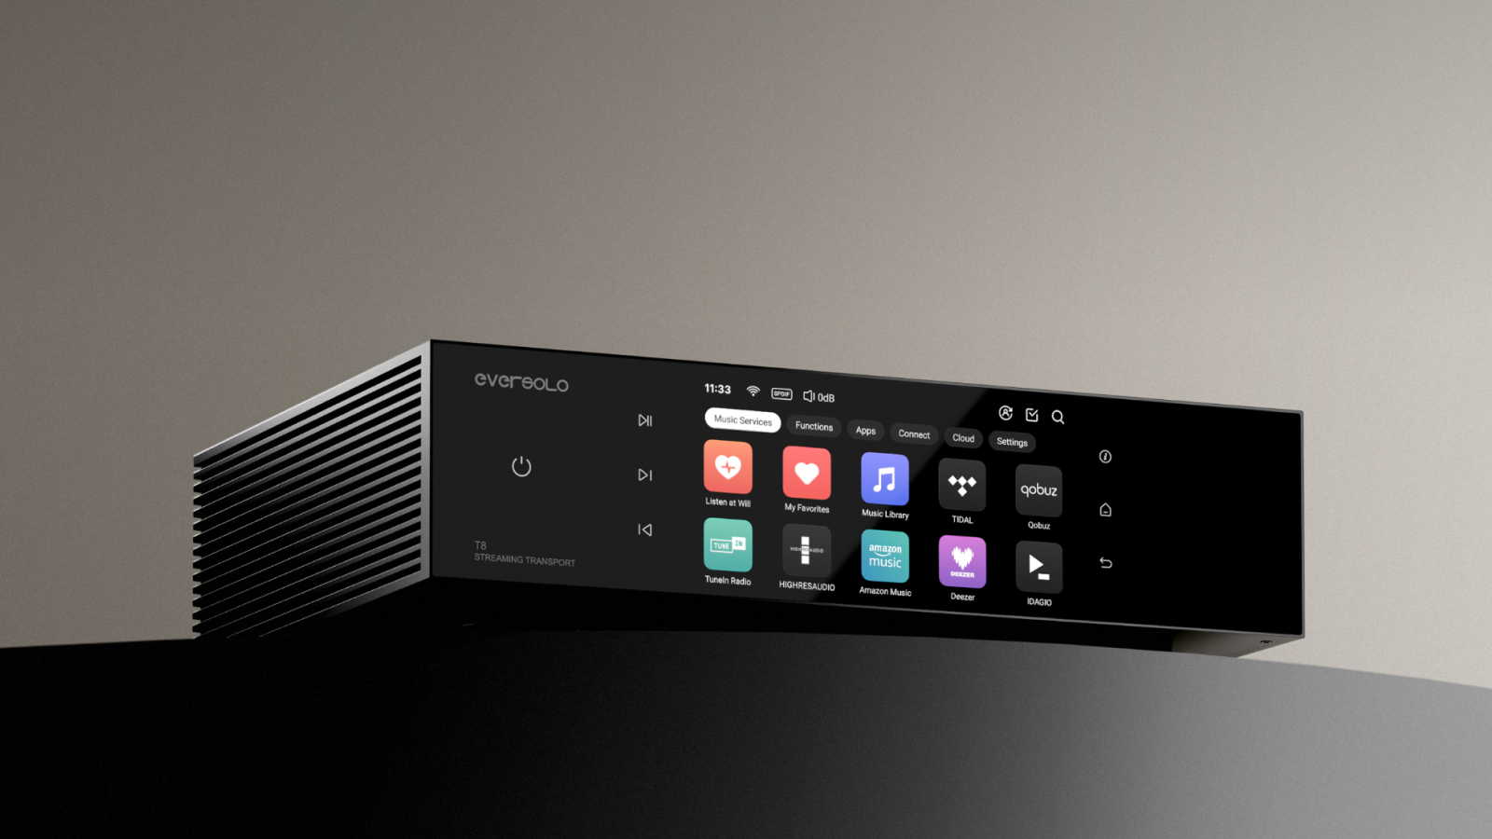

As a pioneering brand in the audio industry, Eversolo has always upheld the philosophy of “faithfully reproducing pure sound,” continuously redefining the Hi-Fi experience through its innovative product architecture. From the widely acclaimed DMP-A6 to the flagship DMP-A10, Eversolo has earned global recognition for its precision in technology and sound. At this year’s Munich High-End Show, Eversolo unveiled four highly anticipated products, capturing the attention of audiophiles worldwide. Among them, the most eagerly awaited professional-grade streaming transport—the Eversolo T8—has now officially launched.

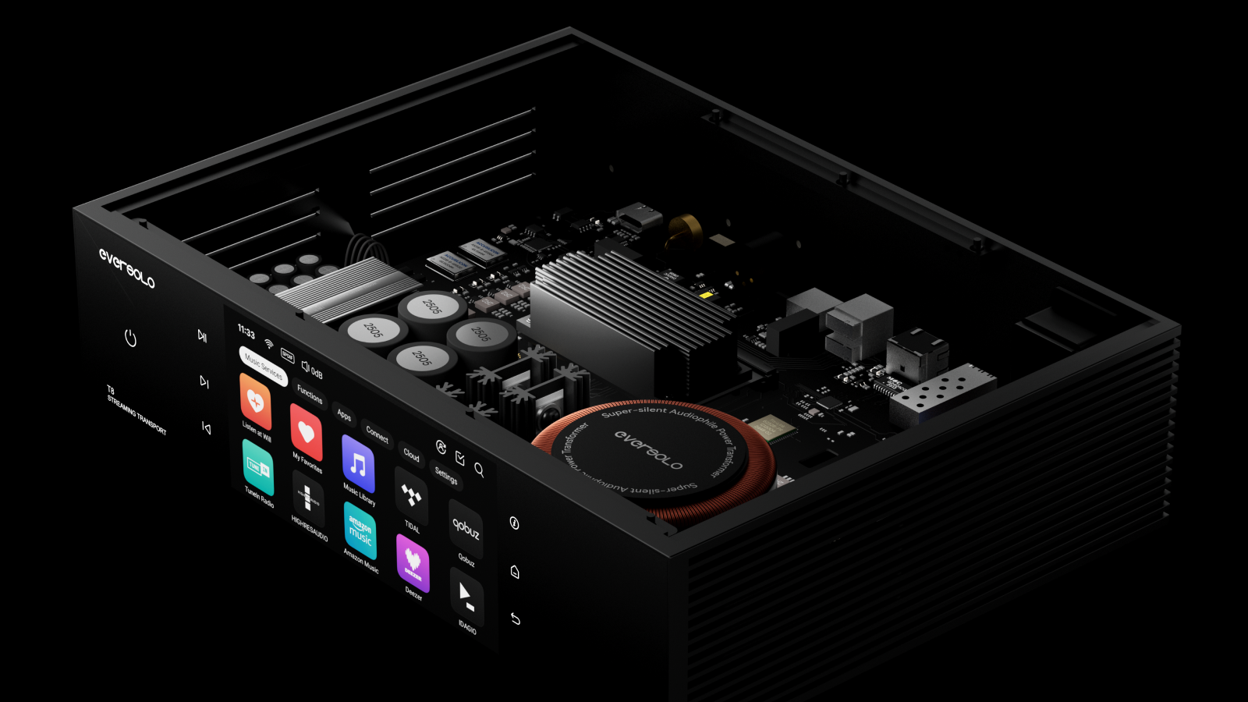

Built on a solid technical foundation, the Eversolo T8 is all about one thing: delivering clean, precise digital audio to your system. Its fully isolated outputs and proprietary software ecosystem offer unparalleled performance for users seeking both purity and versatility, making it the key link in your high-end Hi-Fi setup.

“Eversolo T8 represents our unwavering commitment to pure sound. Every detail—from the femtosecond clock to evotune room correction—has been engineered to ensure that music lovers experience every nuance exactly as the artist intended,” said Spring Meng, CTO at Eversolo.
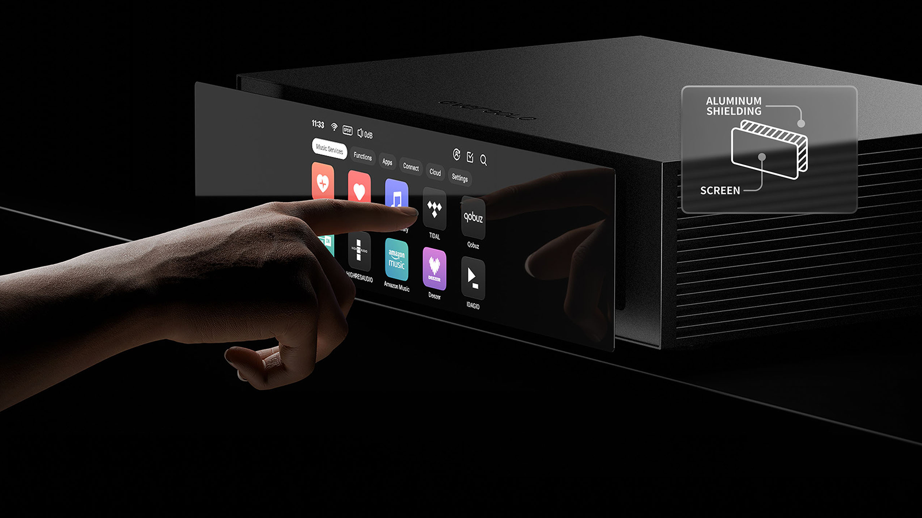
The T8 continues Eversolo’s legacy of high-quality craftsmanship and modern design. Its CNC-machined aluminum chassis offers strength and visual elegance while effectively shielding against electromagnetic interference. The front panel adopts a shielding design that physically isolates it from the internal circuitry, further ensuring clean and pure sound transmission. On the front, a vibrant 6-inch touchscreen paired with full function button controls delivers intuitive, fluid operation. Moreover, the user interface is fully upgraded, ensuring faster response times and a more natural, engaging way to interact with your music.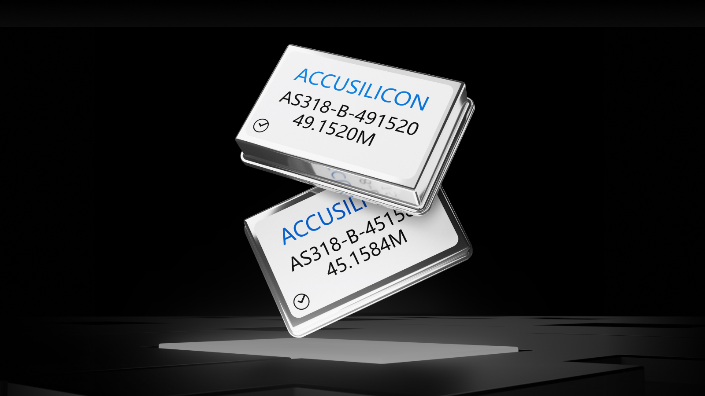
In an audio system, the clock is responsible for managing the timing of every audio sample. Any inaccuracy or excessive jitter can cause blurred sound and a loss of detail. Therefore, the T8 incorporates an ultra-high precision femtosecond clock system—controlling timing with accuracy—delivering focused sound, well-defined imaging, rich detail, and natural dynamics.

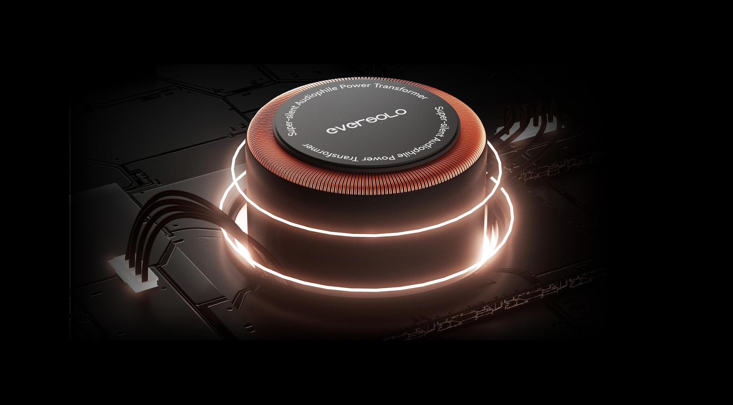

The T8’s super-silent linear power supply reduces noise to as low as 30μV. A custom 4N oxygen-free copper toroidal transformer ensures smooth signal transmission, while Teflon-insulated primary and secondary connections provide high-temperature resistance, superior anti-interference shielding, and ultra-quiet music background, preserving natural dynamics and crystal-clear detail.

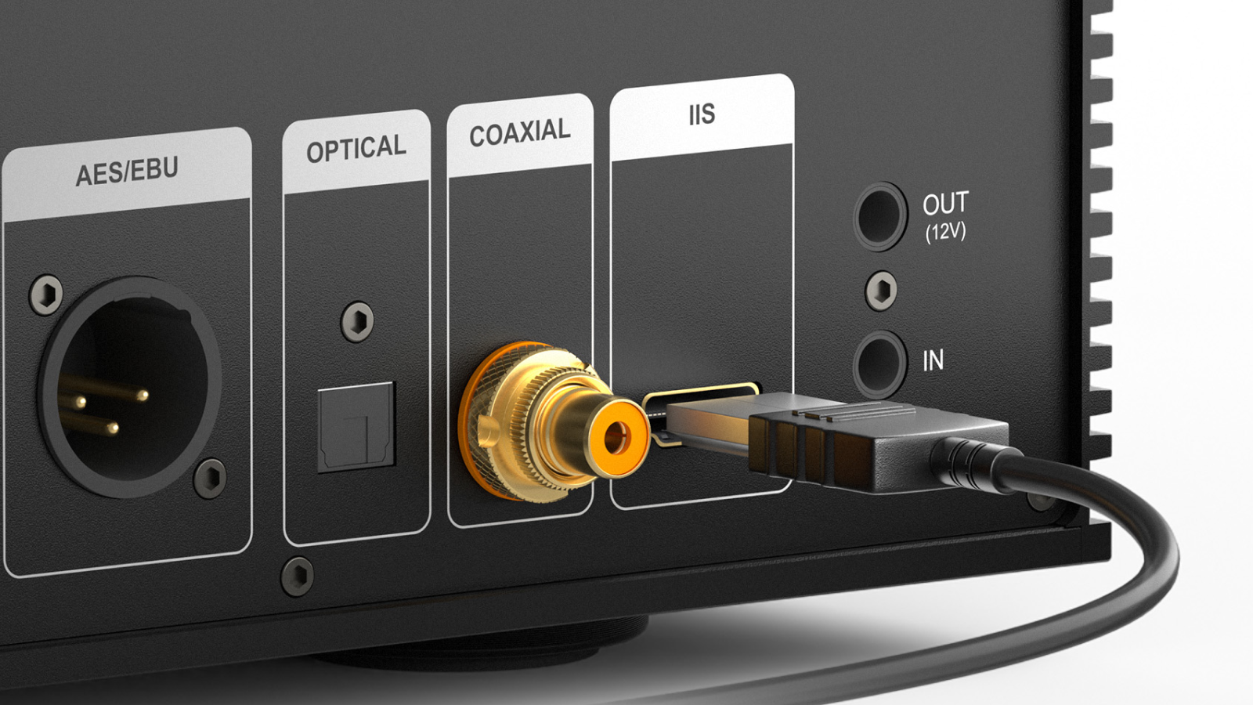
Supporting up to eight IIS output modes, the T8 ensures compatibility with a wide range of DAC brands and models, allowing true plug-and-play operation. Its isolated design blocks power noise and ground loop interference from upstream devices, transmitting only clean, pure audio signals.
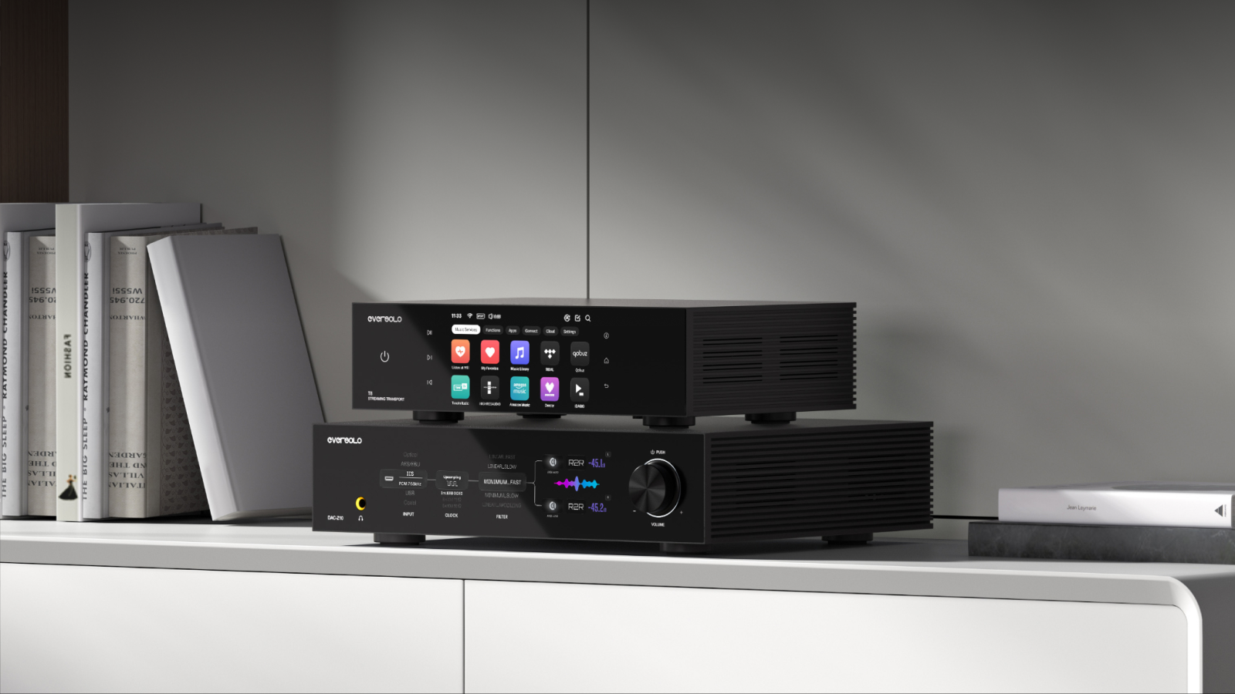

When connecting an external DAC via USB, power noise and ground potential differences can affect the signal, especially if not properly managed. To ensure authentic audio transmission. The T8’s professional USB Audio isolated output creates a protective barrier, fully separating power from audio and transmitting only clean signals for a pure, natural sound.
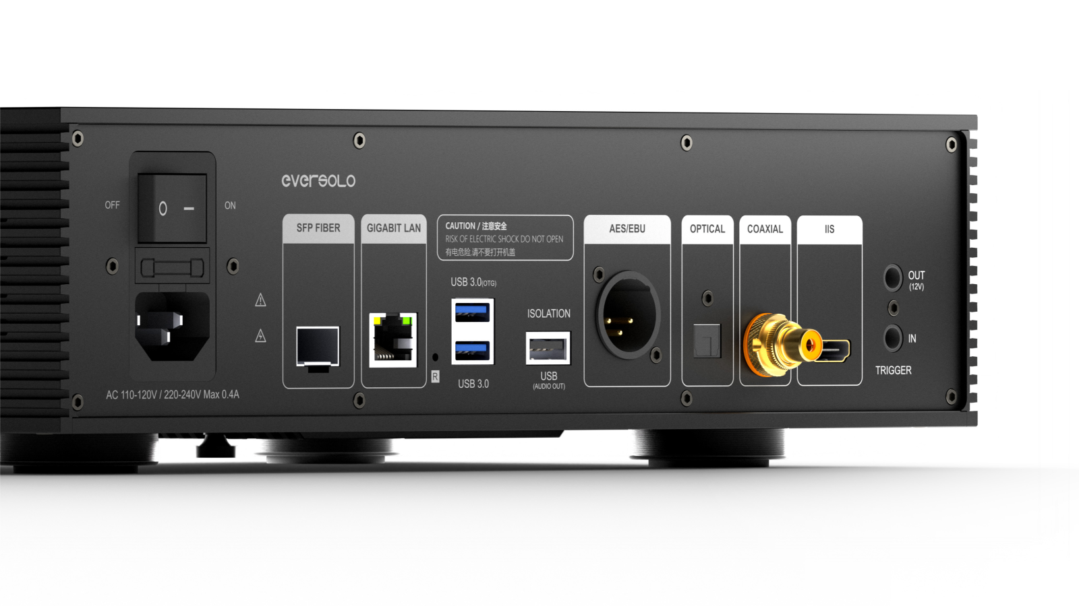
In professional audio environments such as studios and monitoring setups, long-distance digital signal transmission is prone to ground loop currents and electromagnetic interference, causing noise and jitter that affect sound quality. While the T8 features a studio-grade AES/EBU isolated output, providing strong interference resistance and stable signals. Its electrical isolation design prevents noise and jitter, ensuring precise sound reproduction over long distances.

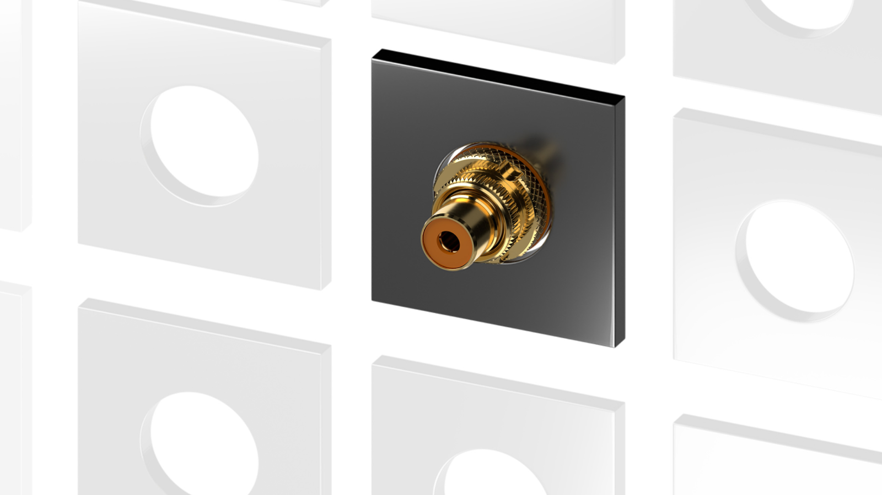

Meanwhile, the T8 employs coaxial isolated transmission up to 24bit/192kHz, effectively blocking interference and ensuring accurate signal delivery. With broad compatibility across DACs and high-end Hi-Fi systems, coaxial transmission has also become the preferred output for many audiophiles.

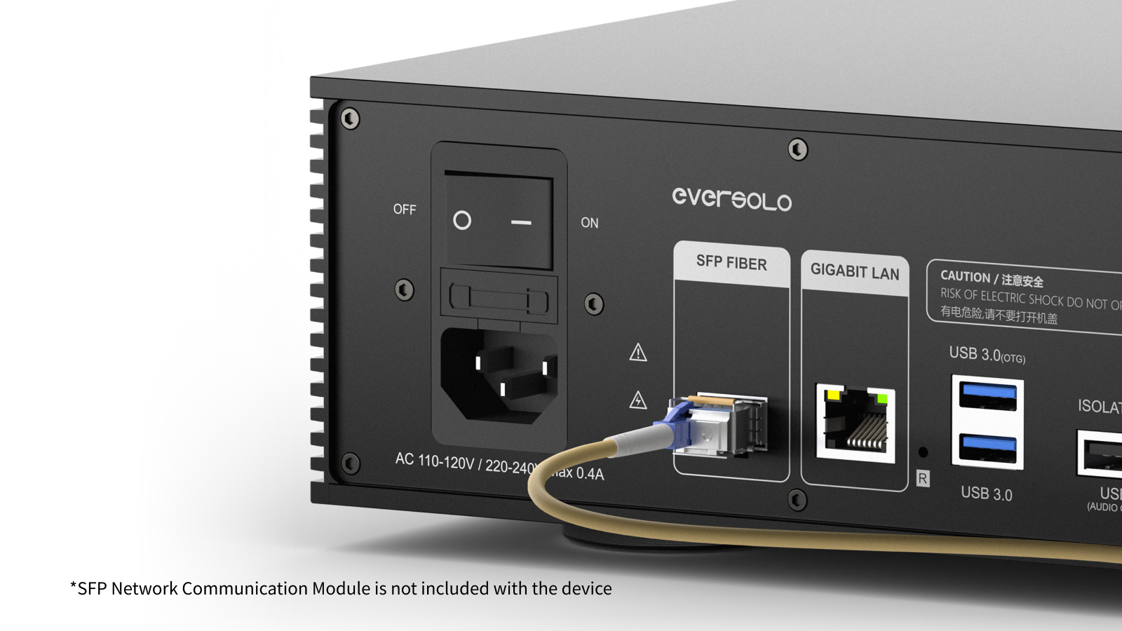

Equipped with SFP network communication module and RJ45 gigabit port, the T8 delivers stable, high-speed audio transmission. SFP module features inherent electrical isolation to shield against electromagnetic interference, fully meeting the demands of Hi-Fi systems.
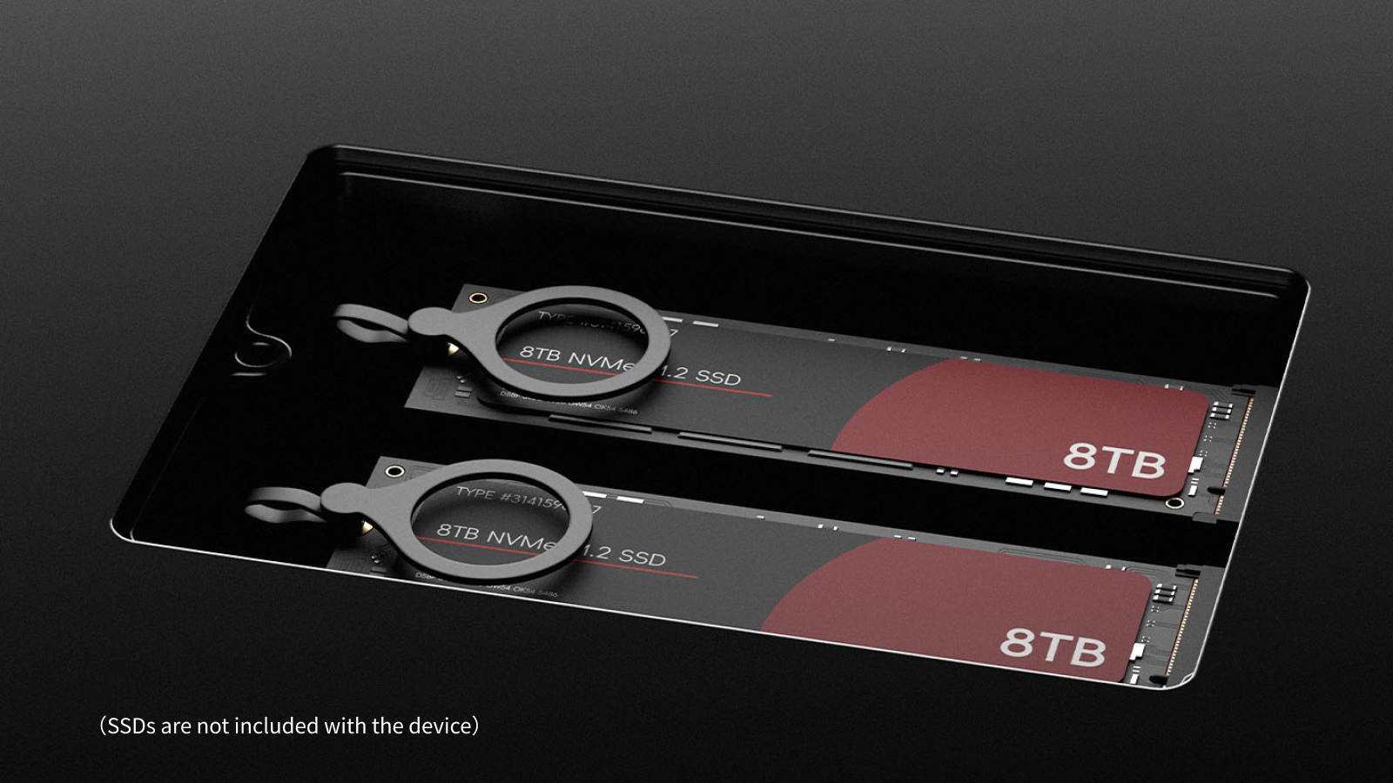

Dual SSD slots support up to 16TB of storage (8TB × 2), enabling gapless playback of large, high-resolution audio files and effortless management of extensive music collections.

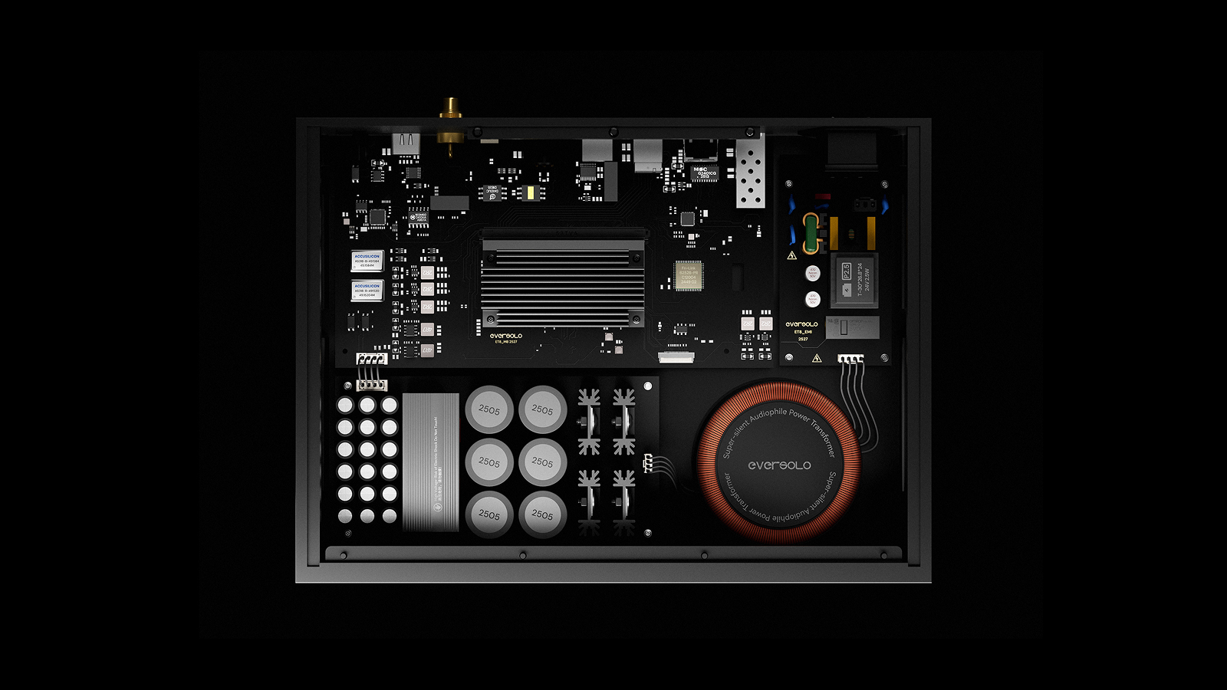

Additional hardware highlights include Wi-Fi 6, a high-performance quad-core ARM processor, and 4GB DDR RAM with 64GB eMMC storage for smooth multitasking and efficient data management.

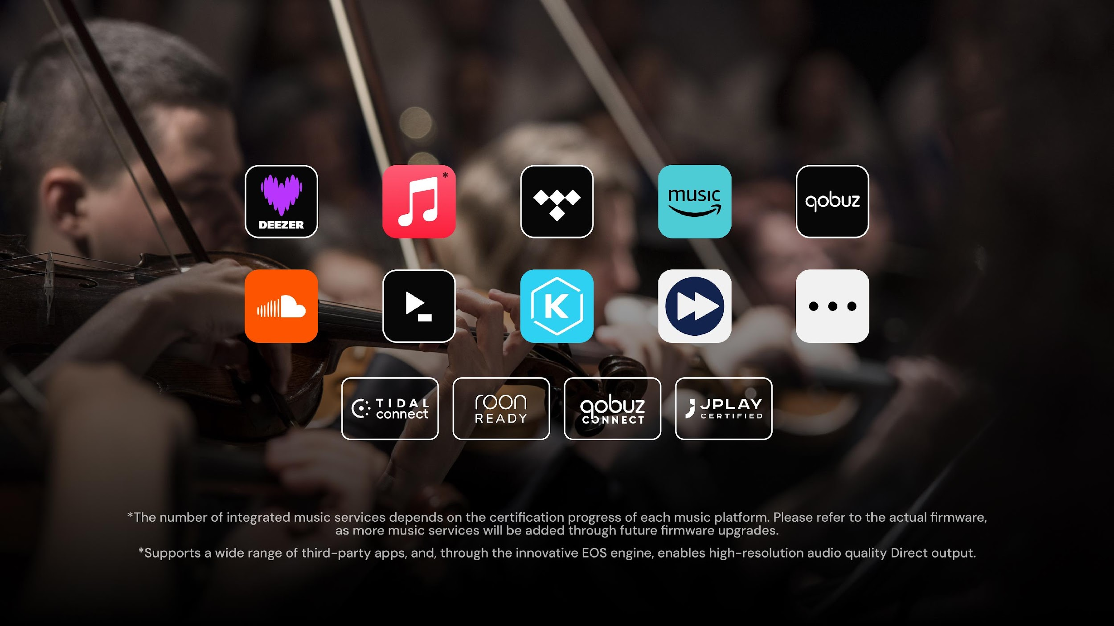

For music lovers, access to multiple streaming services should be easy and convenient. The T8 integrates mainstream music services like TIDAL, Qobuz, Amazon Music, Deezer, TuneIn Radio, and more, catering to all your hi-res listening needs. It also supports TIDAL Connect, Qobuz Connect, and Roon Ready, enabling direct playback from your preferred device for a smooth music experience.

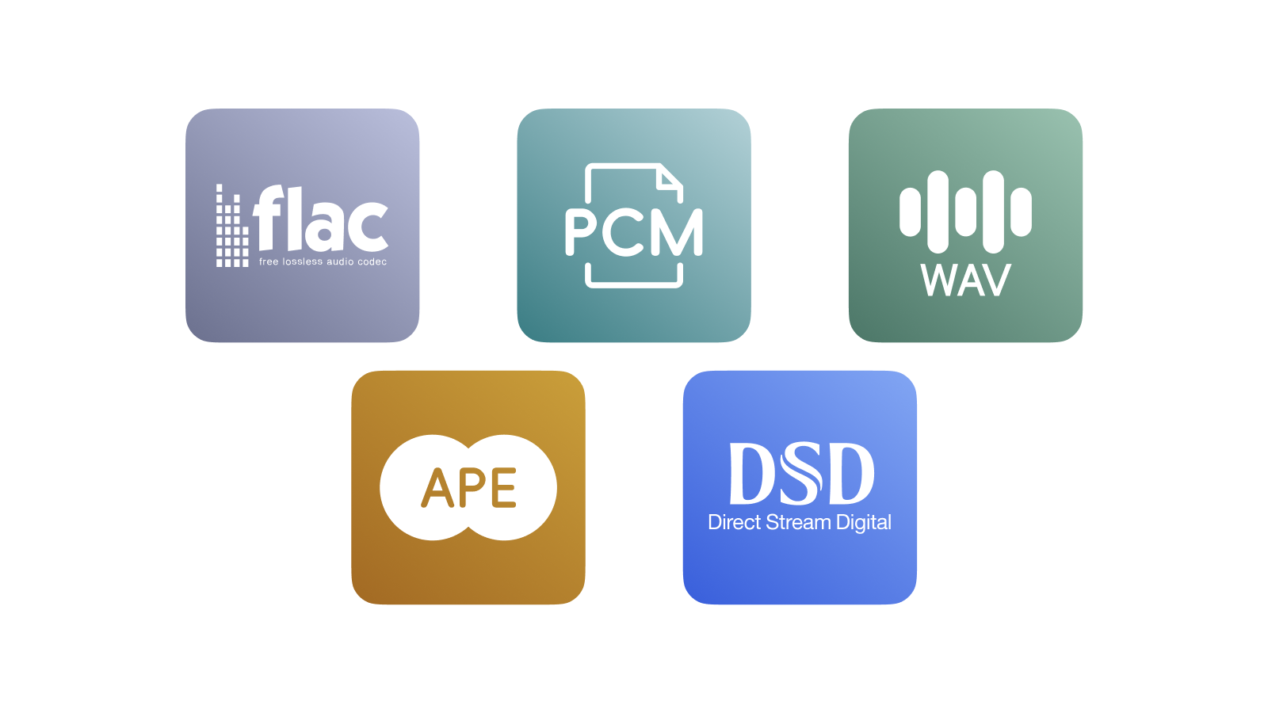
With the Eversolo T8, audiophiles can enjoy high-fidelity formats including DSD, PCM, FLAC, APE, and WAV, supporting up to DSD512 and PCM 768kHz/32Bit. The T8 can be combined with an external DAC, reproducing music with full detail, dynamic range, and amazing accuracy.
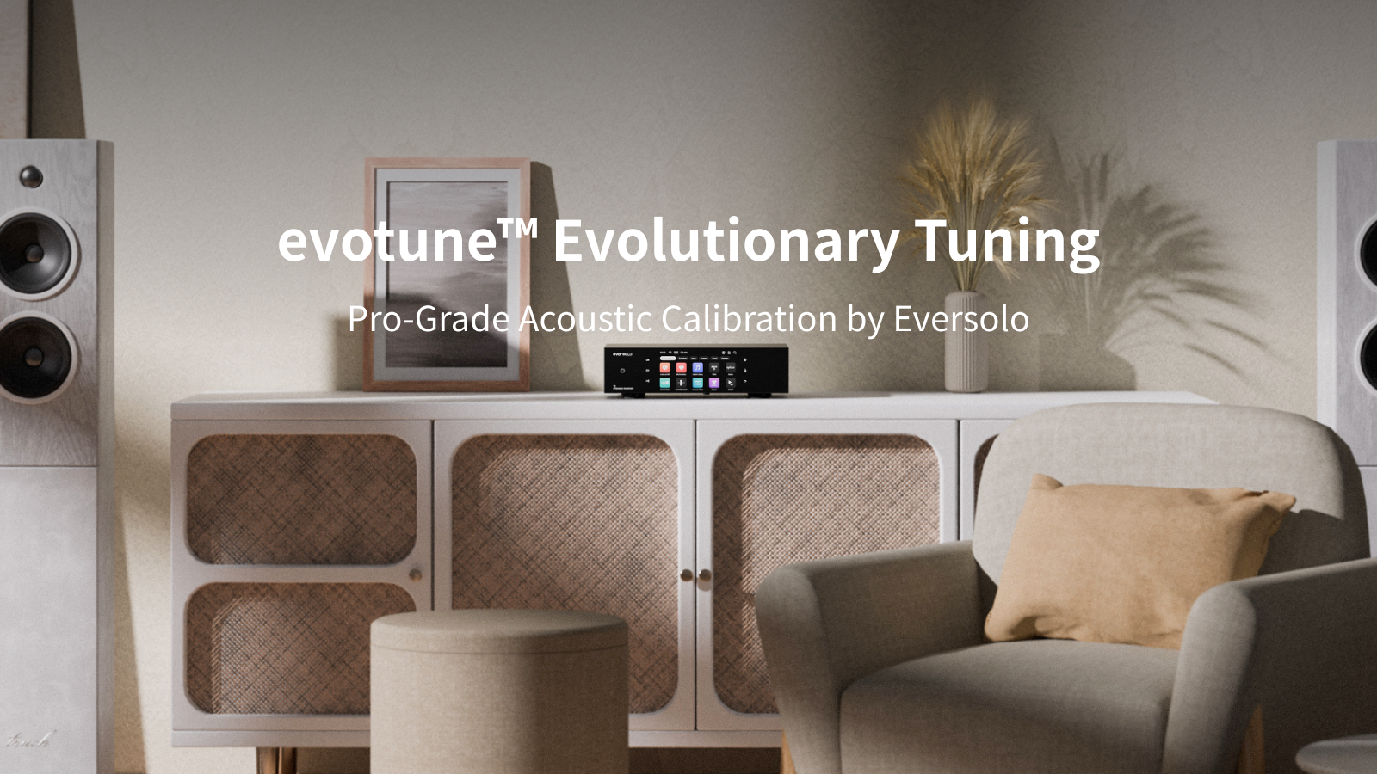

The acoustic environment of a room greatly affects sound; for example, reflections and standing waves can make audio unnatural. The T8 addresses this with professional-grade room correction via Eversolo’s evotune system. Using advanced FIR algorithms, it analyzes room acoustics and optimizes system output. Room correction can be done easily with the Eversolo EM-01 microphone or a smartphone microphone. Evotune overcomes the traditional “equipment depends on the room” challenge, making high-quality sound accessible to all music lovers and audiophiles.

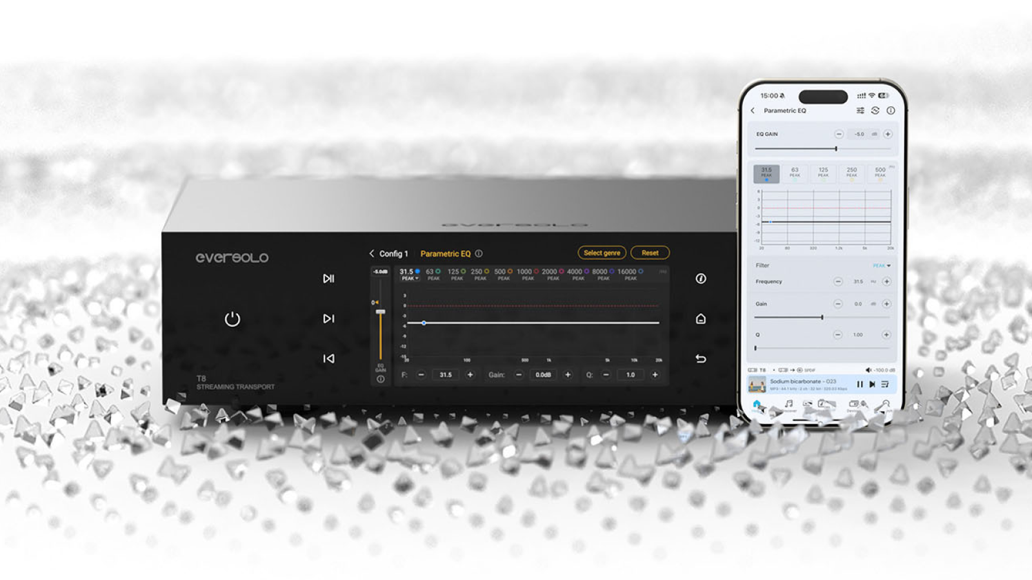

When it comes to sound tuning, the T8 supports a 10-band PEQ module, FIR filter import, and loudness adjustment, allowing users to fine-tune the audio to their liking—emphasizing lows, controlling highs, and achieving the ideal sonic signature.
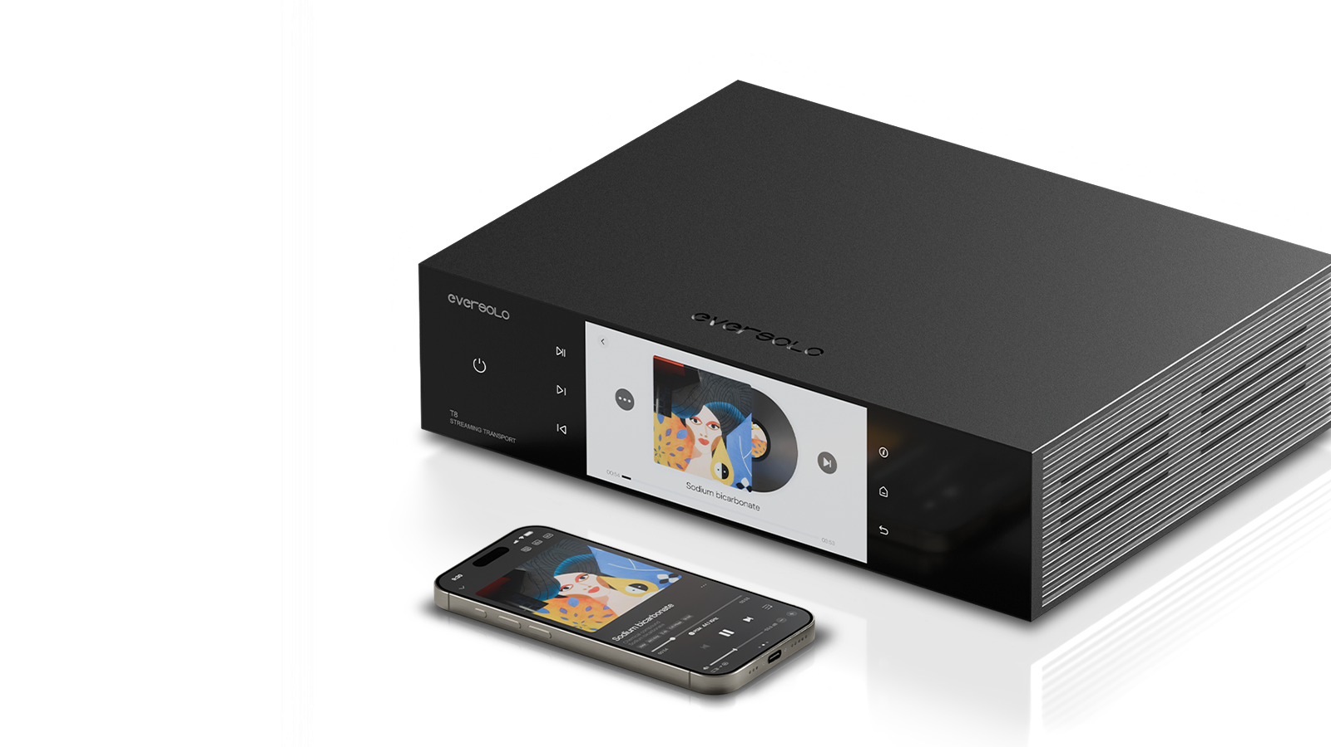
Other features including:
- Support for WOL (Wake-on-LAN), allowing the device to respond at any time.
- Global quick search, making your favorite song available by one click.
- Multi-dimensional music management, automatically extracting and organizing metadata to keep the library tidy, with support for various sorting and browsing options.
- “Listen at will” mode, mixing local and online streaming content for a delightful, surprise-filled music journey.
- Cross-platform playlists, combining your favorite tracks from different music services into one list.
- Easy access to local computers and NAS devices over the LAN.
- Compatibility with popular cloud services such as Dropbox and WebDAV.
- Gapless playback function for your convenience
And many more features waiting to be discovered…
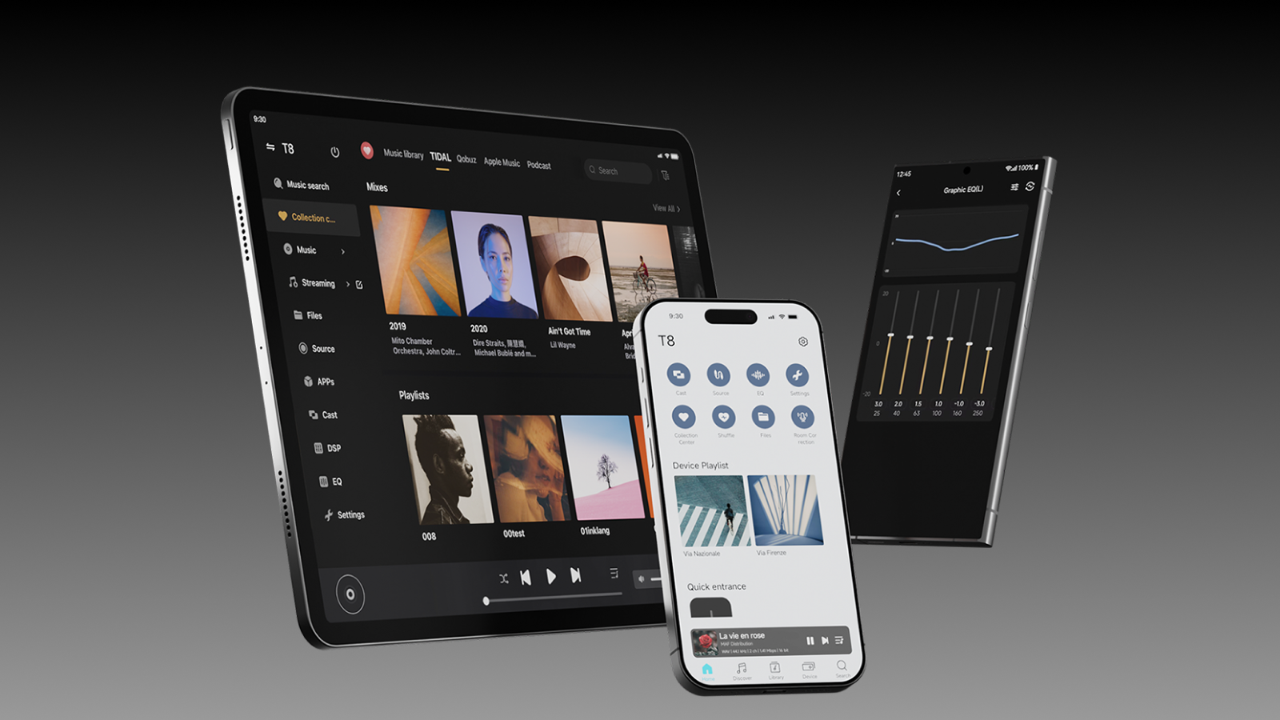

Eversolo Control lets the T8 be easily operated from Android/iPhone, iPad, or M-series MacBooks. The intuitive interface is easy to use and supports real-time screen interaction, so any action performed on the T8 is instantly reflected on these devices, making control seamless and flexible.

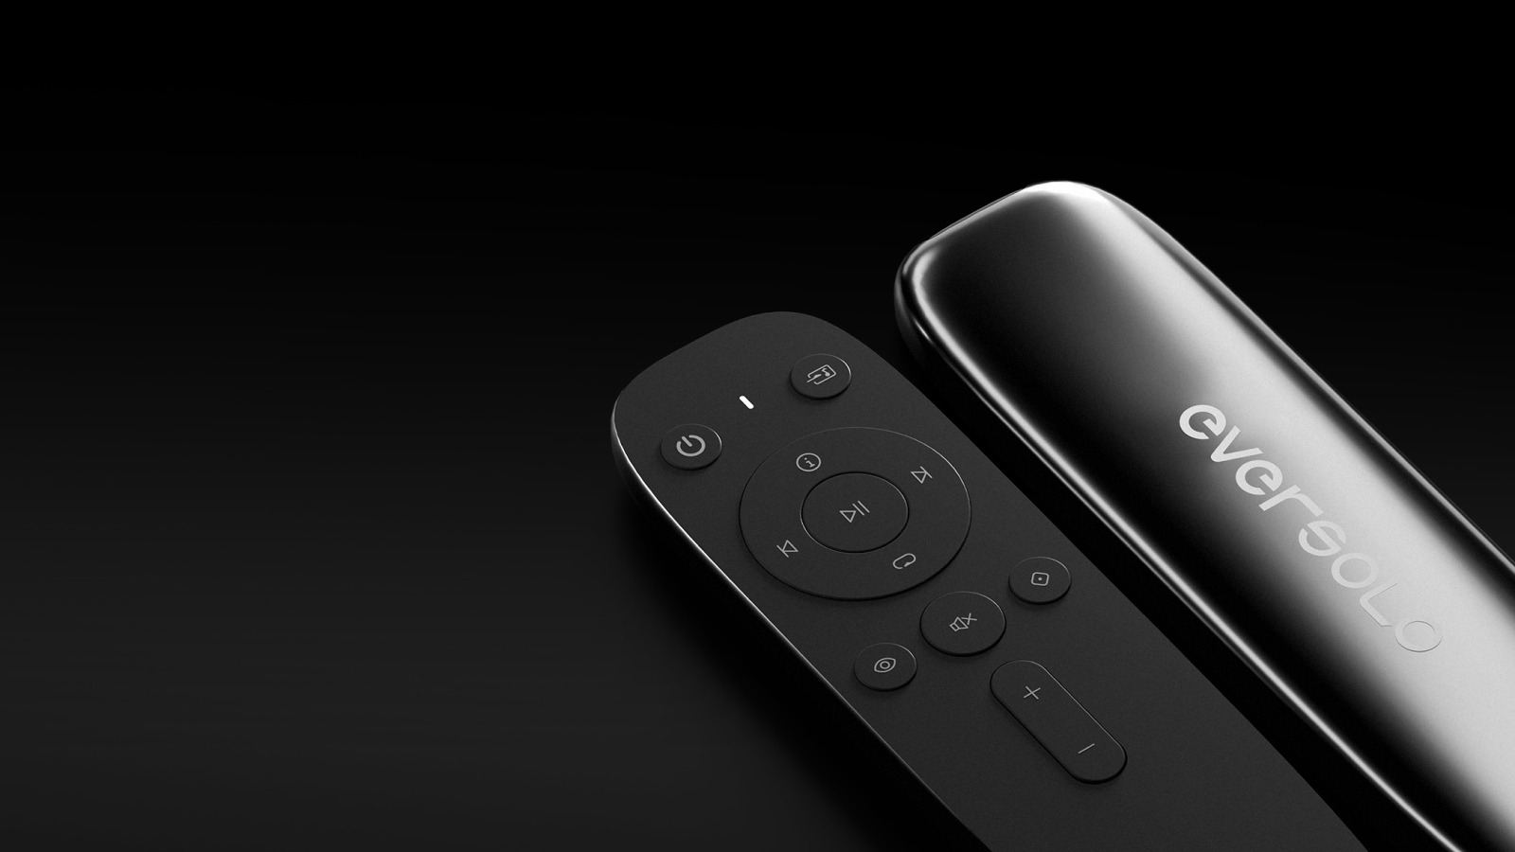

Besides that, the T8 also preserves the premium remote-control experience. Each unit comes standard with a dual-mode Bluetooth/IR remote, ensuring stable operation in line-of-sight conditions while also enabling precise control even when obstacles are present—seamlessly blending convenience with modern functionality.
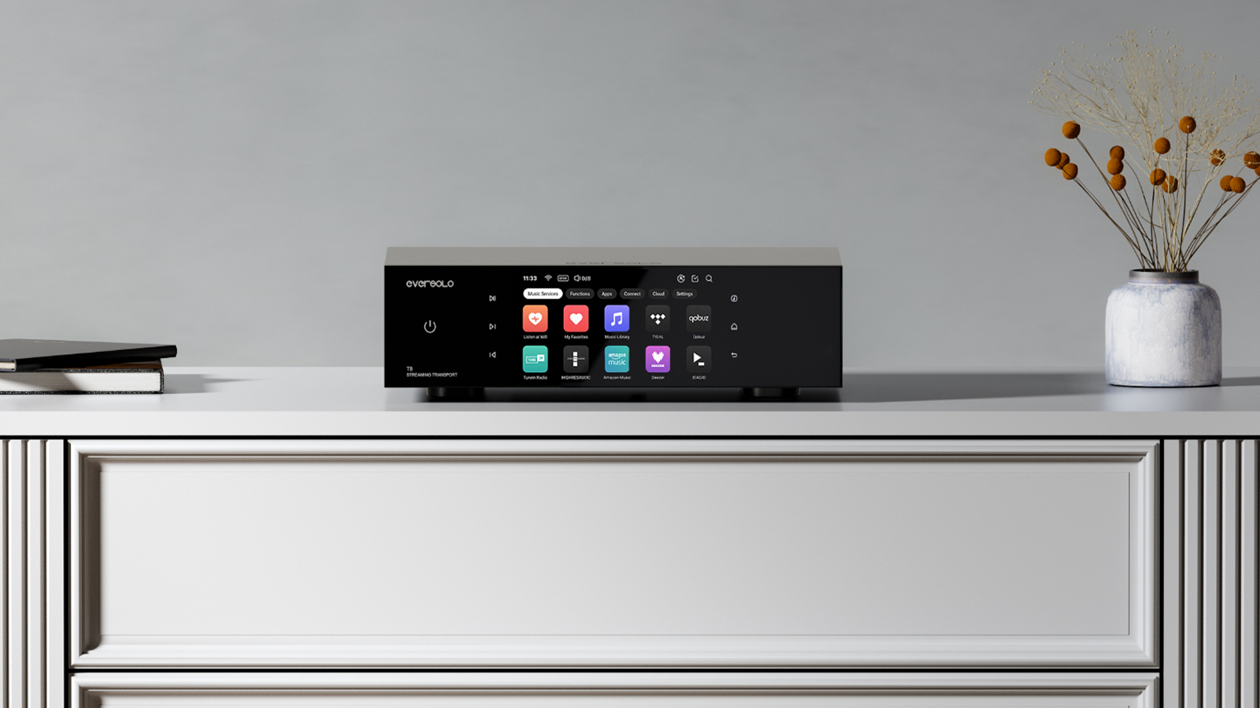

With minimalist design, premium construction, and a pure internal architecture, the T8 transcends the traditional “streamer” concept. As a professional-grade streaming transport, it adapts to various DACs, providing flexibility, depth, and a high-end audio experience for music lovers and audiophiles alike.

Pricing
MSRP: 1380 USD / 1380 EUR

With the full specifications of the T8 now revealed, we believe the official sale is just around the corner. Let’s look forward to its arrival together.

